**Rapid Application Development**

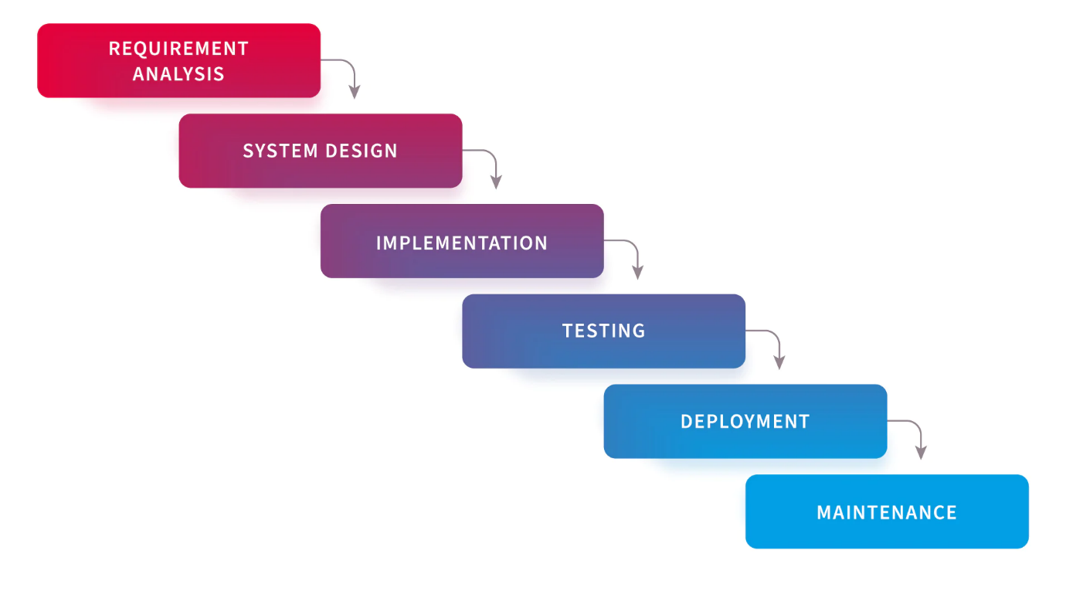

**Work breakdown structure**

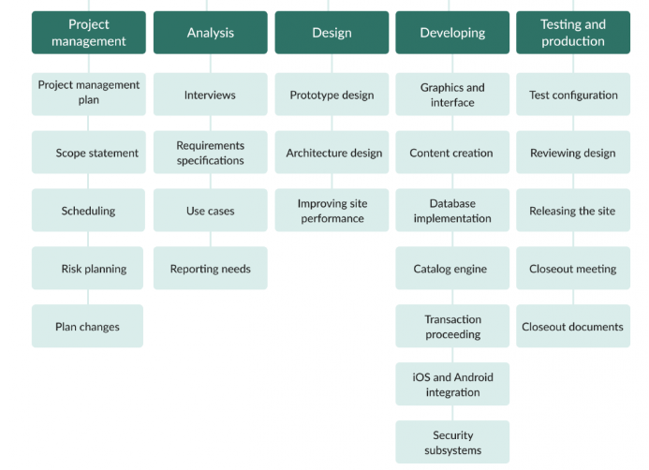As you see, this result-oriented tree work breakdown structure example of a software project focuses on the project management, analysis, designing, developing, and testing stages.

* **Project management**. The first stage of our work breakdown structure for software project example includes planning, defining scope, scheduling, risk management, and work with possible plan changes.
* **Analysis.** At this stage, project teams conduct required interviews, work on requirements specifications, and prepare use cases.
* **Design** is one of the most essential parts of our software development work breakdown structure example. Here, you should care about the prototype design, architecture design, and site performance improvements.
* **Developing.** This is typically one of the most active phases of software development, so you will need to thoroughly work on developing the new e-commerce site and care about all the details, meaning graphics and interface, content creation, database implementation, catalog engine, transaction processing, iOS and Android integration, security, and other important issues.
* **Testing and production** are what end the process. This is when test configuration, reviewing design, releasing the site, closeout meetings, and preparing closeout documents happen.

**Project model**

